

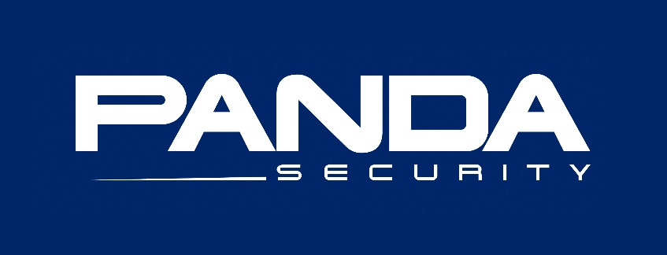

[This Photo](http://commons.wikimedia.org/wiki/File:Panda_Security_Logo.jpg) by Unknown Author is licensed under [CC BY-SA](https://creativecommons.org/licenses/by-sa/3.0/)

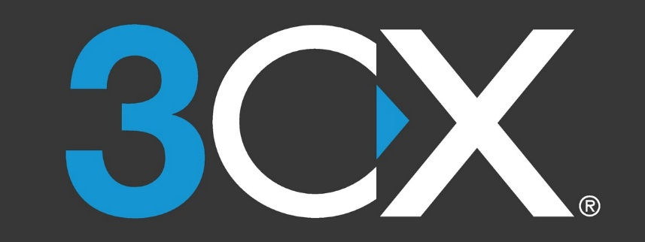

[This Photo](https://en.wikipedia.org/wiki/3CX_Phone_System) by Unknown Author is licensed under [CC BY-SA](https://creativecommons.org/licenses/by-sa/3.0/)

***WHAT IS CYGOOSE TRIPLE-THREAT-PROTECTION?***

It’s an A.I. Based software that learns your organization’s computer/user environment and behaviors. The ongoing intelligence provides cyber threat protection, system maintenance and optimization ability. Most equipment & software failures are a result of old equipment and/or under maintained equipment. The software also creates alerts and reporting providing aide to existing IT Support if exists. TRIPLE-THREAT-PROTECTION does not include remote & onsite support; however, all packages below offer TRIPLE-THREAT-PROTECTION. This requires an annual commitment.

***Managed Subscription Package = TERA Savings!!***